Project Manual

Enterprise Resource Planning Application

Advisor: Bui Duy Khiem

Team: Kraken Force

Class: C1812G

--------------------------

Toan Ngo Vu Thanh

Dat Tien Do

Tuan Doan Le Nha

Huy Ho Van

October 2020 - Kraken Force®️

***Table Of Content:***

1. Acknowledgements 3
2. Project Synopsis 3
3. Project Analysis 4
4. Project Design 4
5. DFD
6. Flowcharts
7. Process Diagram
8. Database Design / Structure
9. Screenshot 5
10. Authentication Module
11. Warehousing Manage Module
12. Customer Manage Module
13. Sales Manage Module
14. Statistic Module
15. User Guide 14
16. Authentication Module

* Create New User
* Login
* Forget The Password

1. Warehousing Manage Module

* Warehouse List Manage
* Unit List Manage
* Product Group Manage
* Product Manage
* Product Discount Manage
* Warehousing Manage
* Inventory Manage
* Delivery Module

1. Customer Manage Module

* Customer List Manage
* Trade Discount List Manage
* Order List Manage

1. Sales Manage Module

* Salesman List Manage
* Receipt List Manage
* Payment List Manage

1. Statistic Module

* Customer List Statistic
* Trade Discount List Statistic
* Product Group Statistic
* Sales Statistic

1. Developer’s guide 26

***Privacy terms:***

* This application is owned by KrakenForce. All unauthorized users and organizations are held accountable under the laws of the host country
* We will not collect information of individuals and organizations using this application, and will not use any unauthorized form to collect information. All customer information is safe. We guarantee it



[**Enterprise resource planning (ERP)**](https://www.oracle.com/applications/erp/) refers to a type of software that organizations use to manage day-to-day business activities such as [accounting](https://www.oracle.com/applications/erp/financials-cloud.html), [procurement](https://www.oracle.com/applications/erp/procurement-cloud.html), [project management](https://www.oracle.com/applications/erp/project-portfolio-management-cloud.html), [risk management and compliance](https://www.oracle.com/applications/erp/risk-management-cloud.html), and [supply chain operations](https://www.oracle.com/applications/erp/what-is-erp.html). A complete ERP suite also includes [enterprise performance management](https://www.oracle.com/applications/performance-management/), software that helps plan, budget, predict, and report on an organization’s financial results.

ERP systems tie together a multitude of business processes and enable the flow of data between them. By collecting an organization’s shared transactional data from multiple sources, ERP systems eliminate data duplication and provide data integrity with a single source of truth.



This **ERP system application** is made available to small business users. With basic functions such as: user functions, warehouse management, customer management, sales management, statistics and related matters.

The application will cover the most essential requirements for small business management

With a simple, intuitive user interface, you can get acquainted quickly. We always want to give customers the best values

The project is created by KrakenForce Team with 4 members



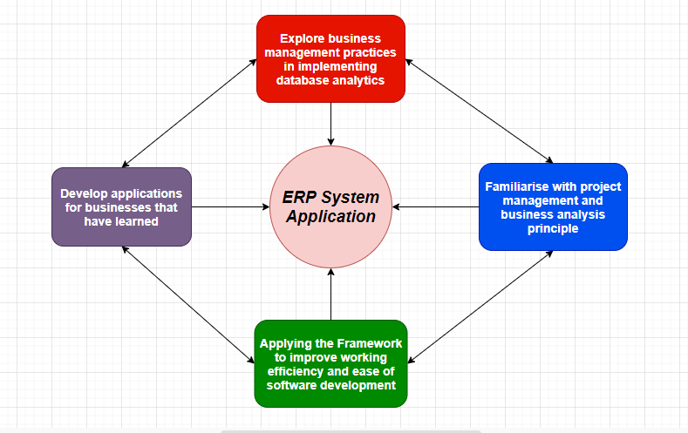



1. DFD (Data Flow Diagram)

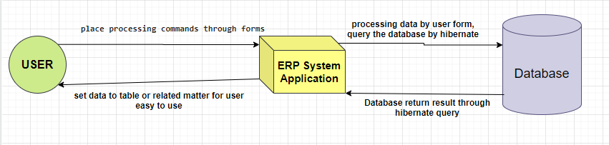

1. Database Design / Structure

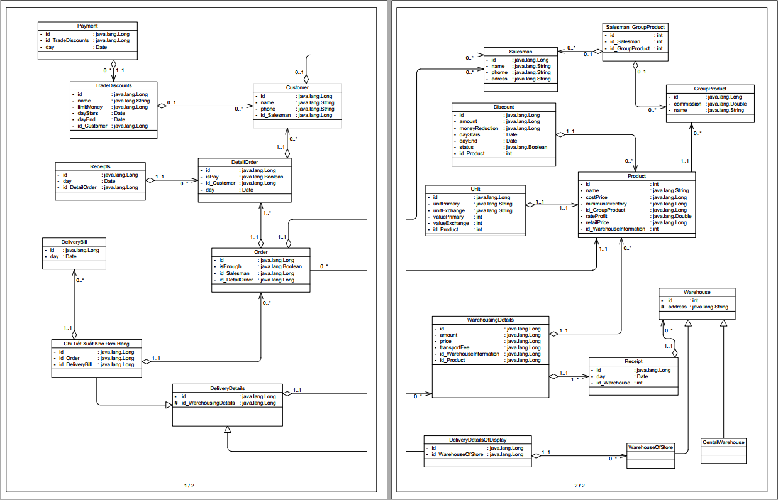

Detail Info: [ERP_System_Features](https://docs.google.com/spreadsheets/d/1Z_2y1cFIoHThF72wDXjkEQjqjmB626lJ69WA85pN29Q/edit?usp=sharing)



1. **Authentication Module**

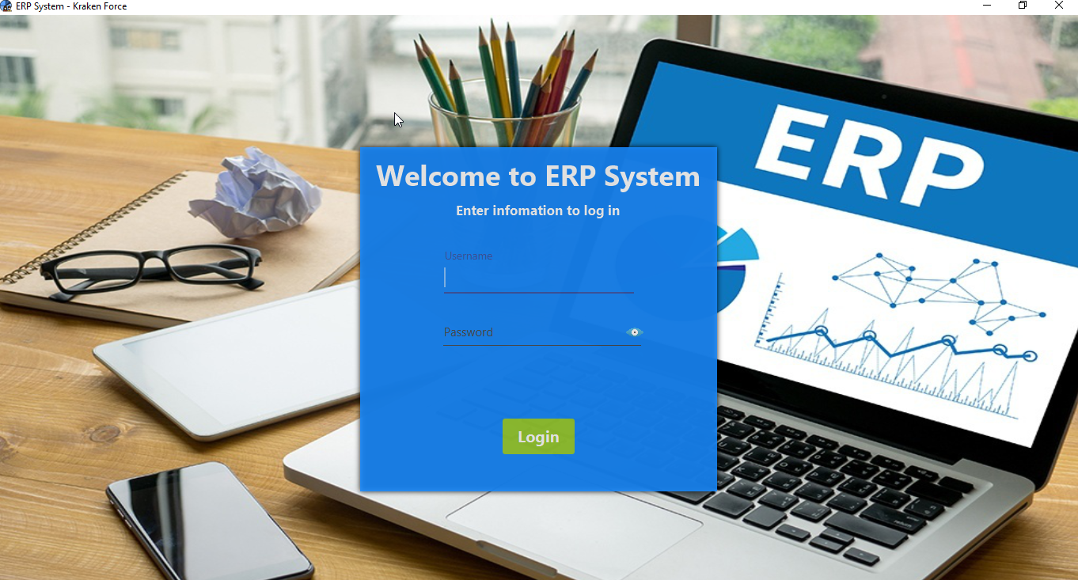

Login page

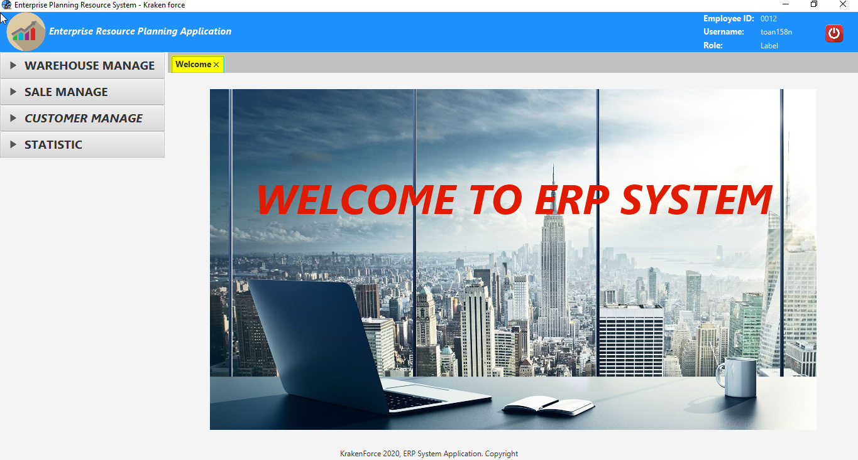

Main UI

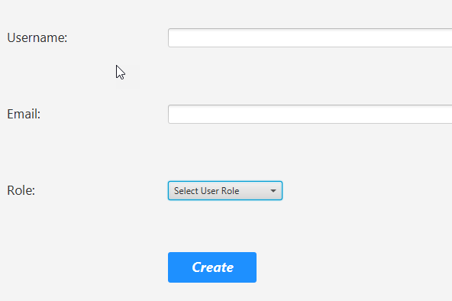

1. **Warehouse Manage**

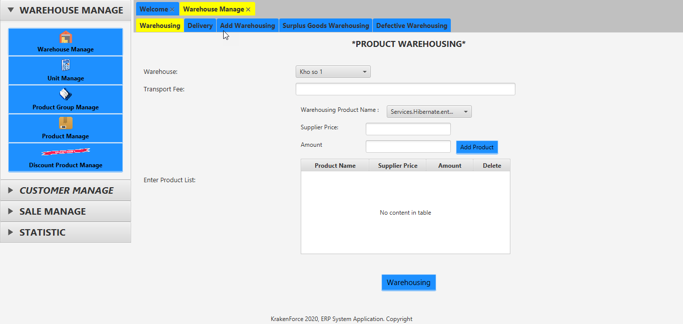

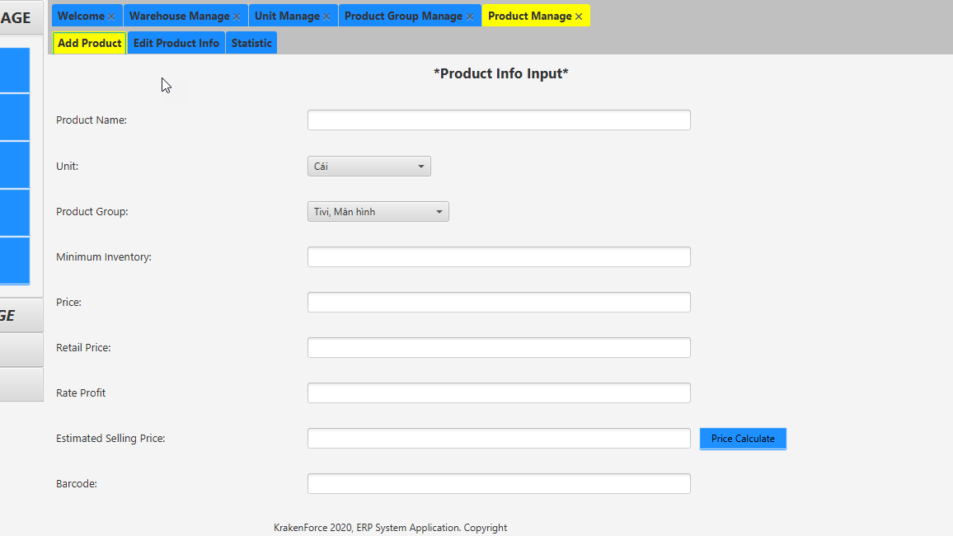

1. **Customer Manage**

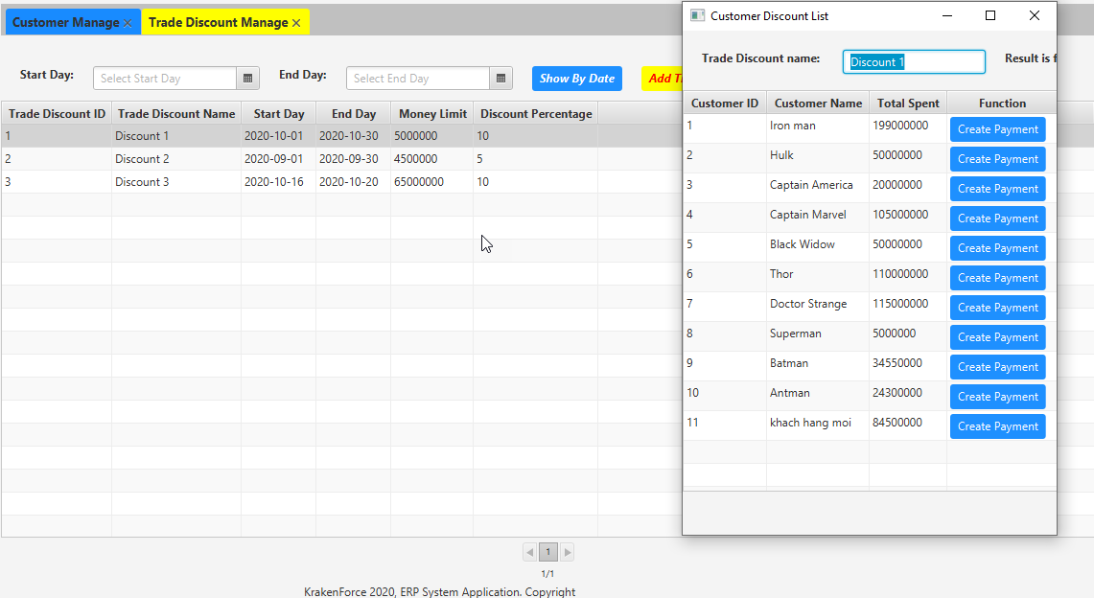

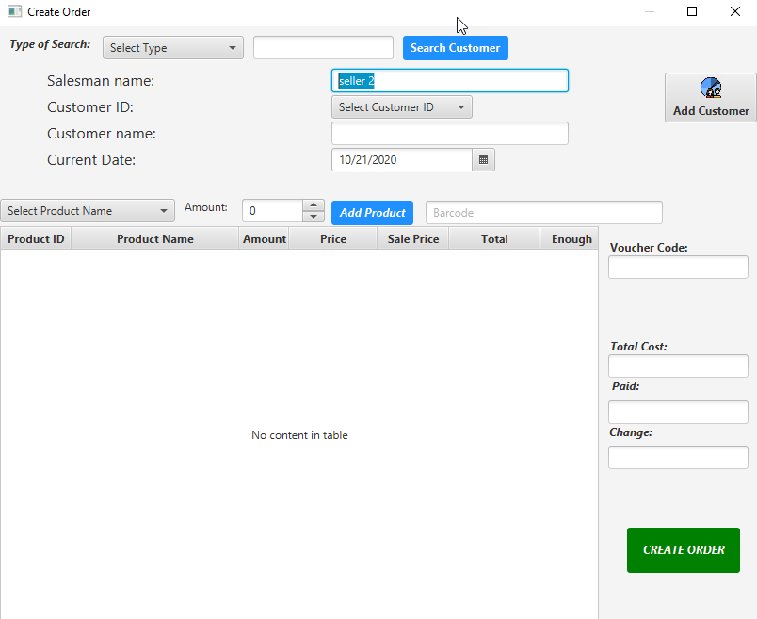

1. **Sales Manage**

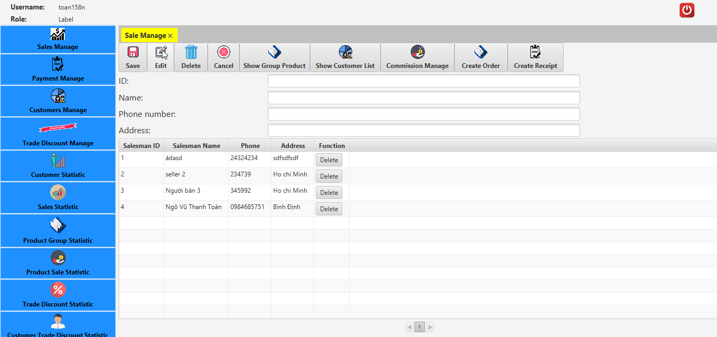

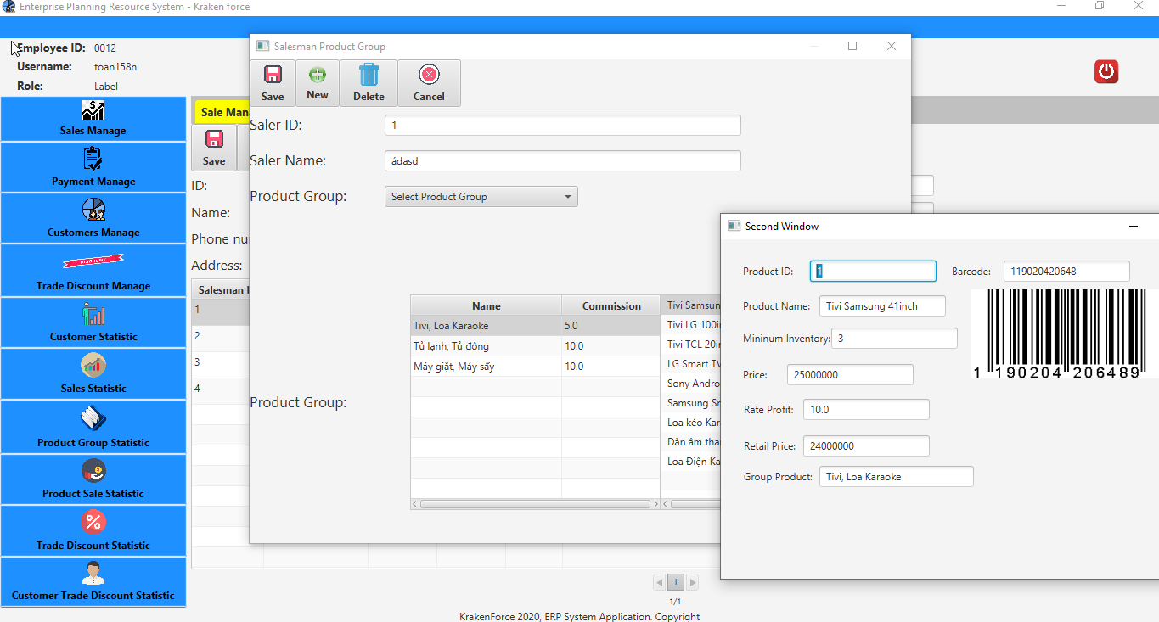

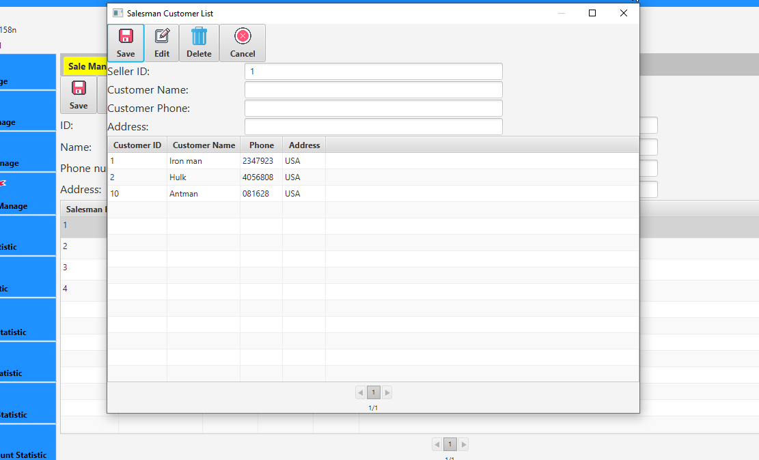

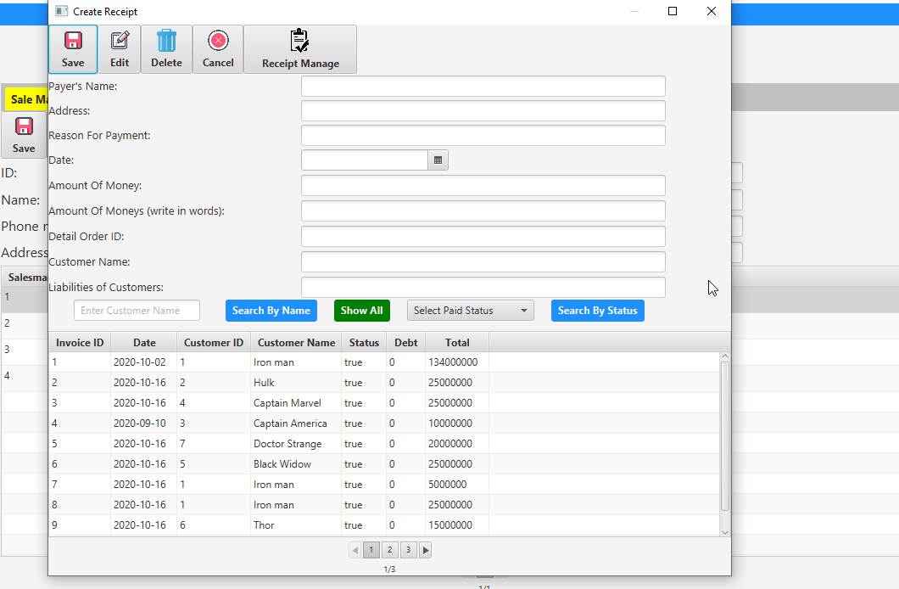

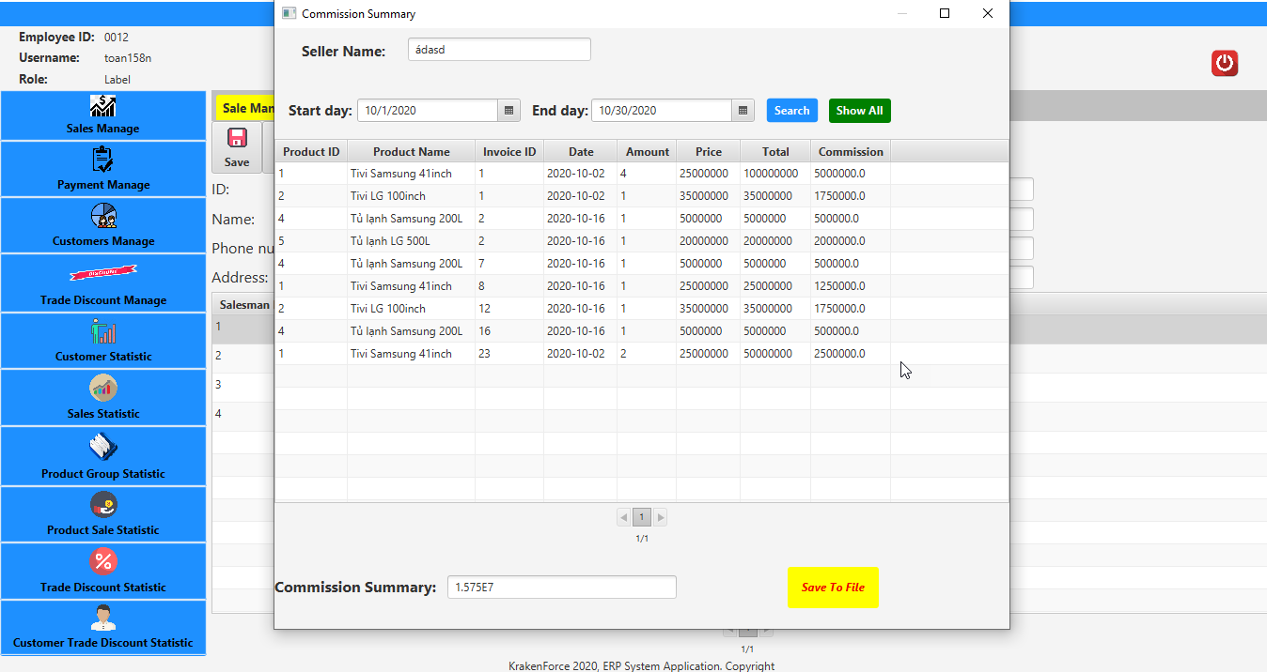

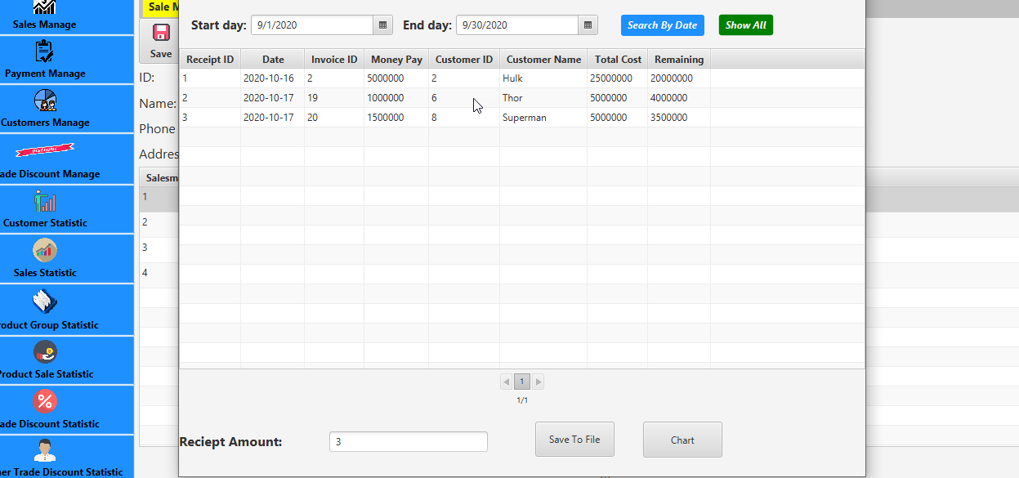

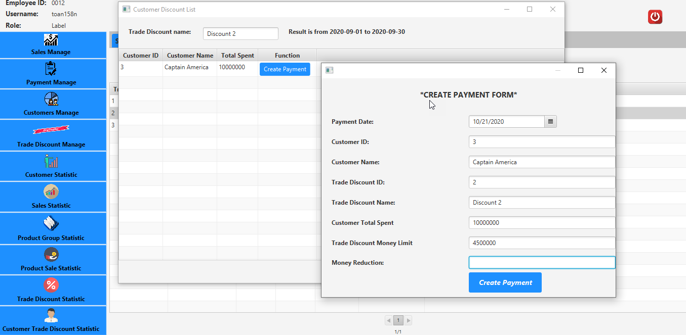

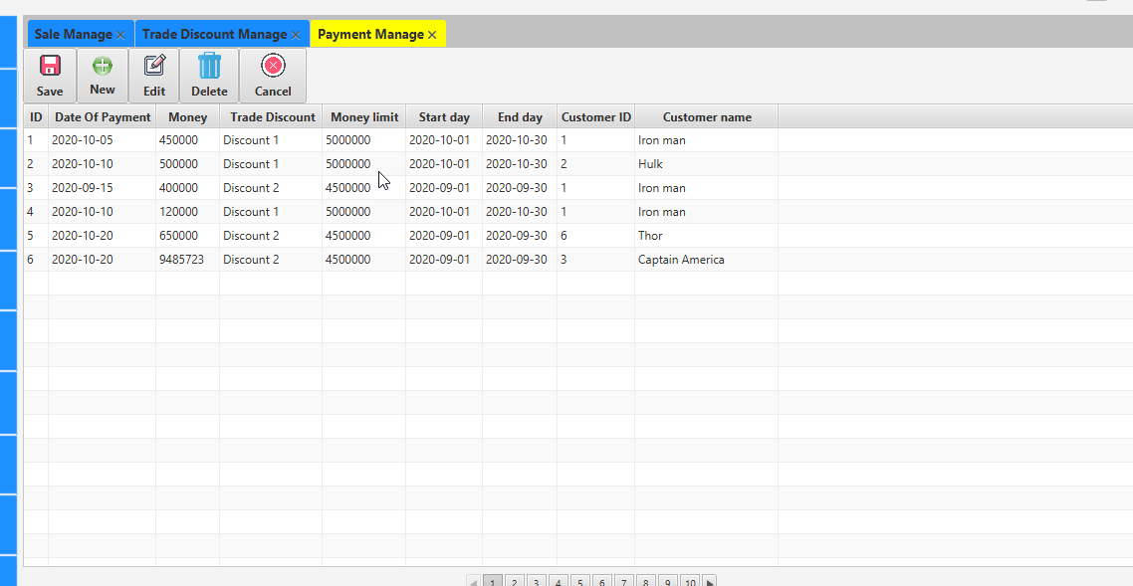

1. **Statistic**

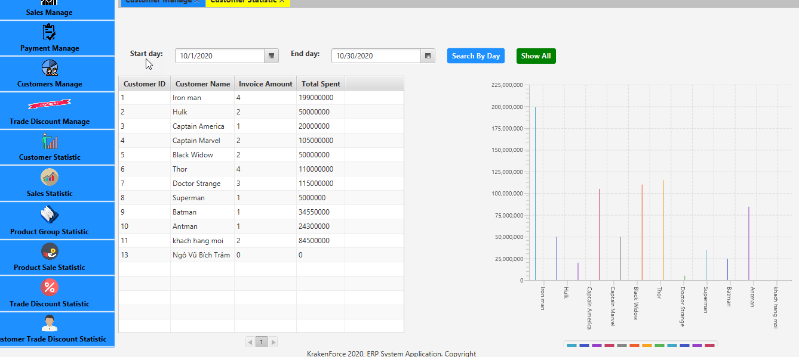

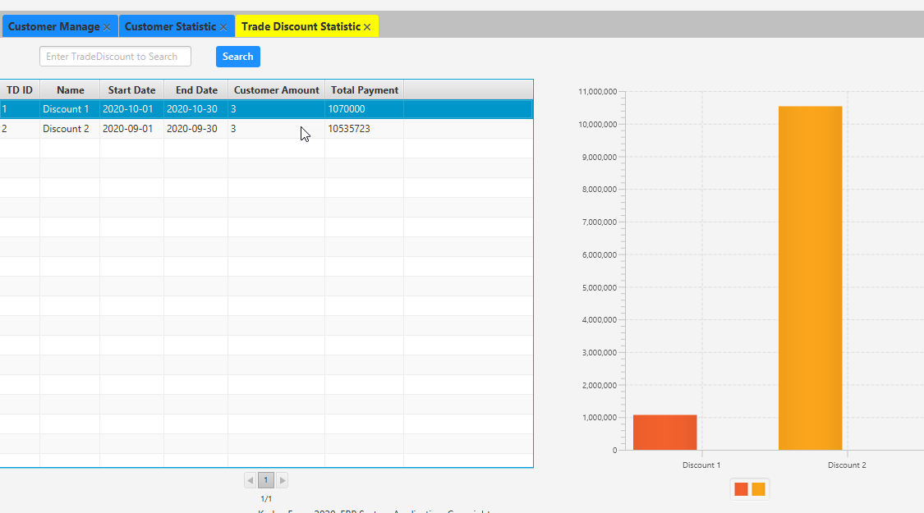

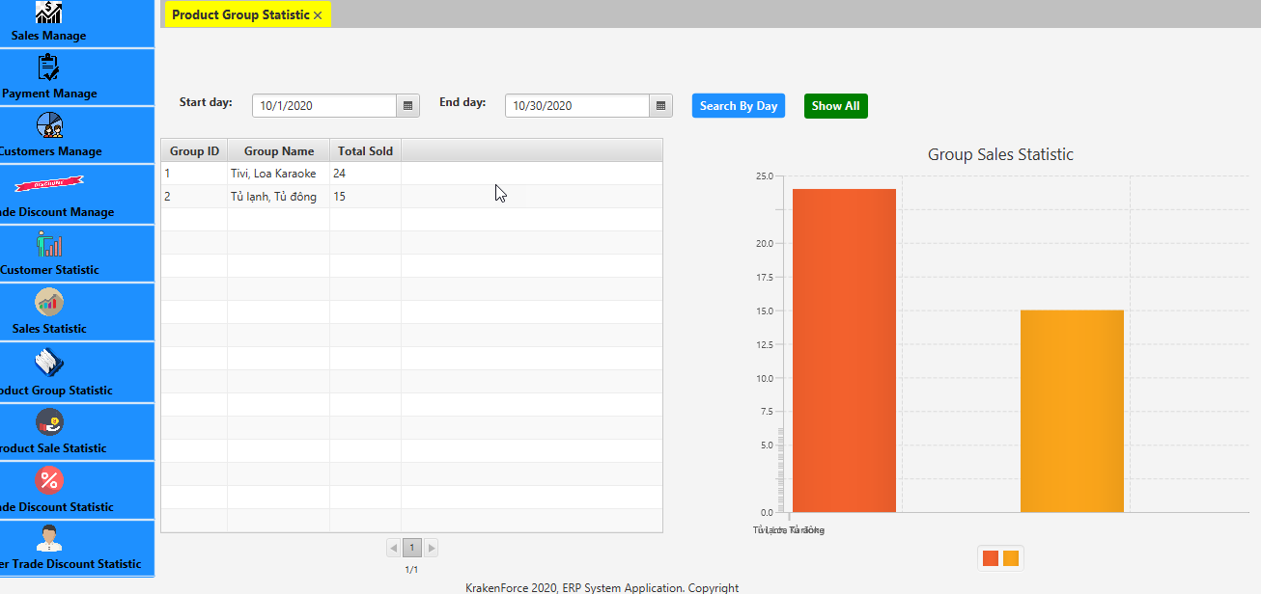



1. **Authentication**

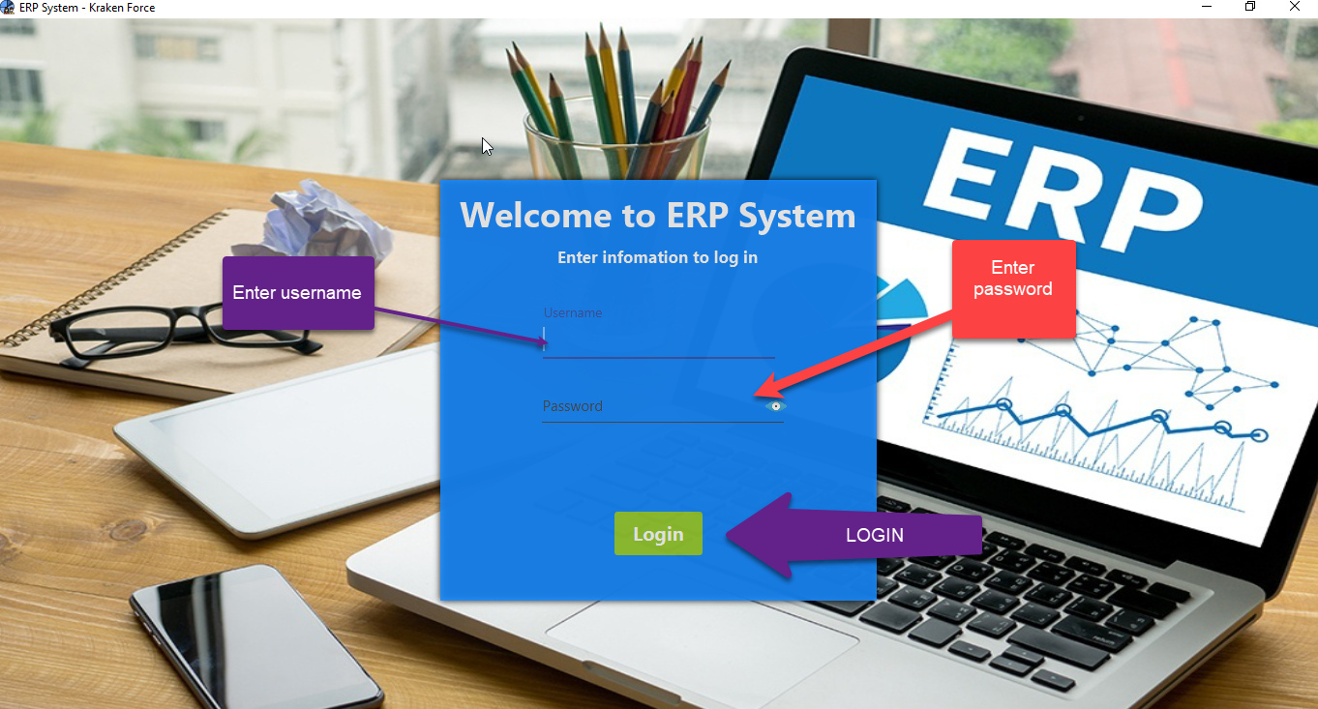

Enter username and password (click to eye icon to show password), click to Login Button or press enter to Login to System, if wrong username or password, it will show a alert dialog.

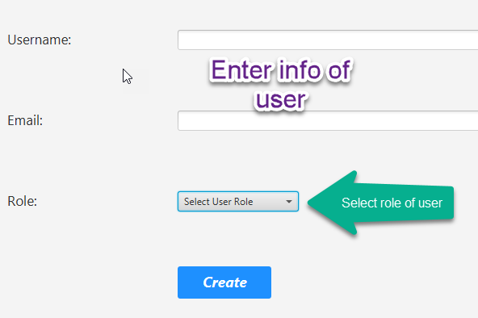

Enter username, email and select role of user(admin, stocker, accountant, salesman,manage ). The system will generate password for user. To create user, click to Create button.

1. **Warehouse Manage**





Our members will demo live because this feature is quite complicated

1. **Customer Manage**

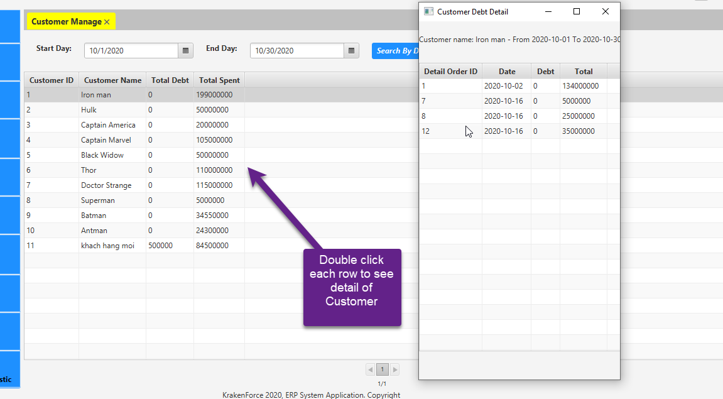

Select start day and end day to get Customer List with total debt and total spent that have order in selected time, double click on each row to see invoice detail, if debt of invoice is 0, you can’t create receipt, if debt greater than 0, the info will parse to Create Receipt form to create receipt.



* **Discount List Manage:**



select start day and end date to get the trade discount that be deployed in time, double click row to see which customer that have total spent reach the limit of trade discount. You can create payment for that customer by clicking on “Create Payment” button.

* **Order Management**



This is create order form

1. **Sales Manage**

* **Salesman List Manage:**



user can add, delete, update info of salesman

* **Salesman Product Group List**



user can add, remove Product Group that salesman can sell, and can see all product of that group product

* Salesman Customer List



Show all or select time range to see commission of salesman in that time

* **Receipt Manage**



Receipt create



* **Payment manage:**



1. **Statistic**

* **Customer List Statistic**

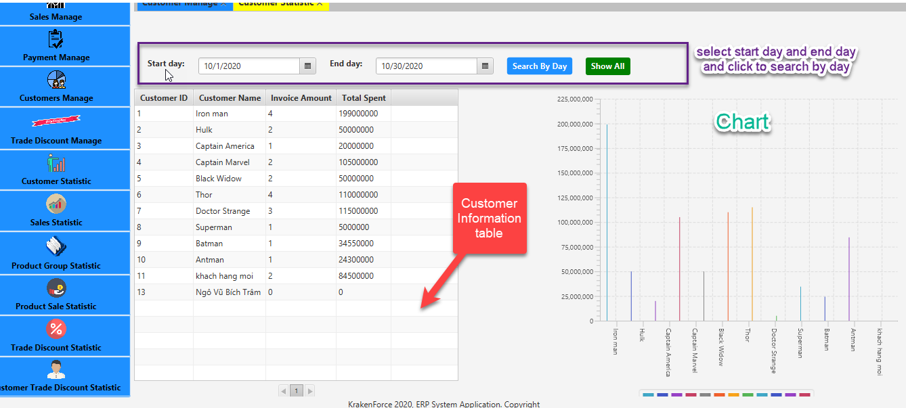

Select start day and end day and click to Search By Day to see invoice amount and total spent of customer in selected time, the chart will automatically generate by date on table. To show all info of customer of all time , click into Show All button

* **Trade Discount List Statistic**

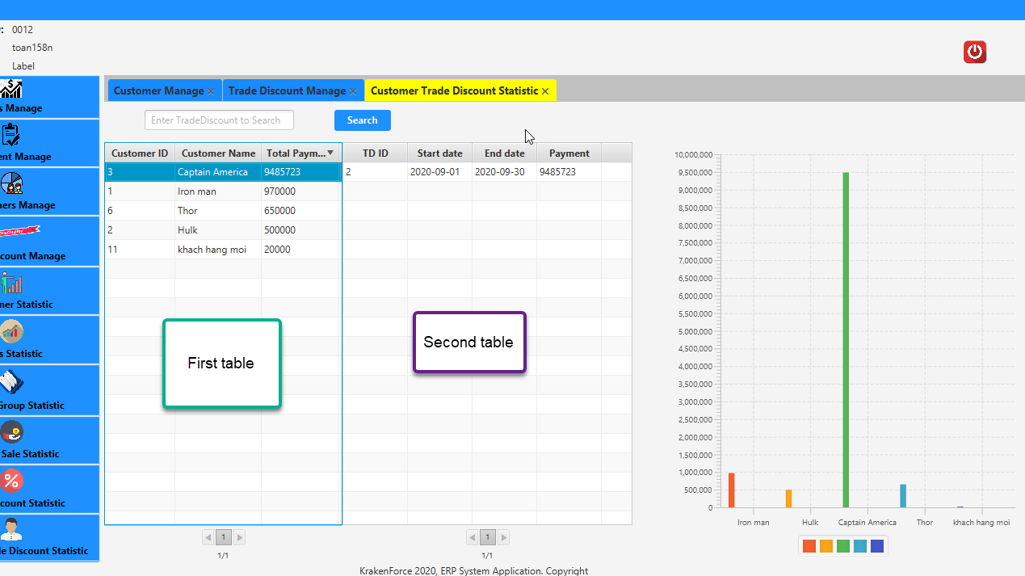

This will show list of Customer with total Payment in all of trade discount. When you double-click on each row on first table, the second table will show list of trade discount and its payment by customer be selected on first table

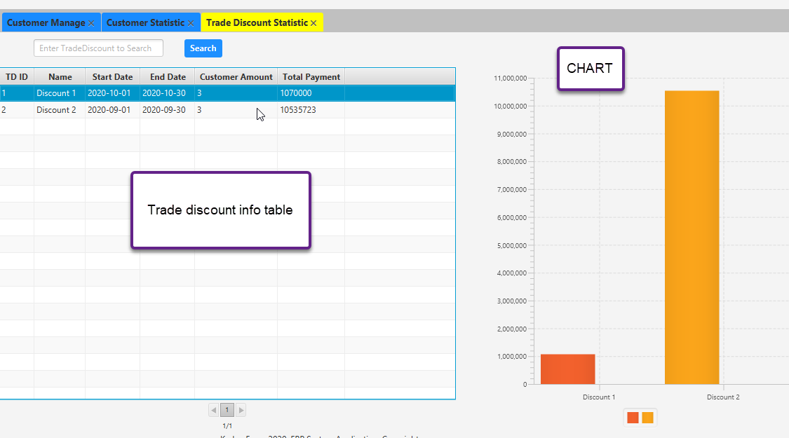

This will show trade discount list with information of trade discount and amount of customer reach the trade discount’s money limit and total payment of that discount, the chart will automatically generate by data on table. If you want to search discount, you can enter trade discount name and click search (you must enter exactly trade discount name - no need to care to letter case ).

* **Product Group Statistic**

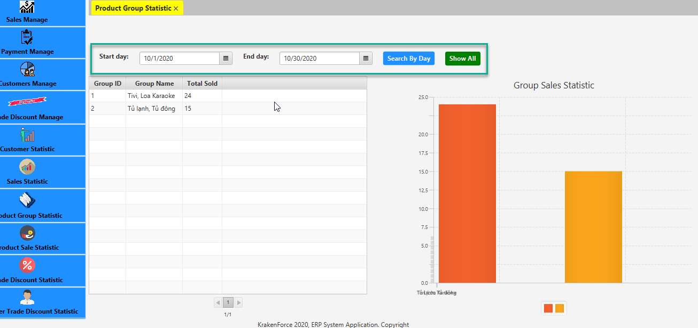

This will show the list of product group and total sold of that group by specific time range been selected by start day and end day DatePicker

When click on each row, you will see

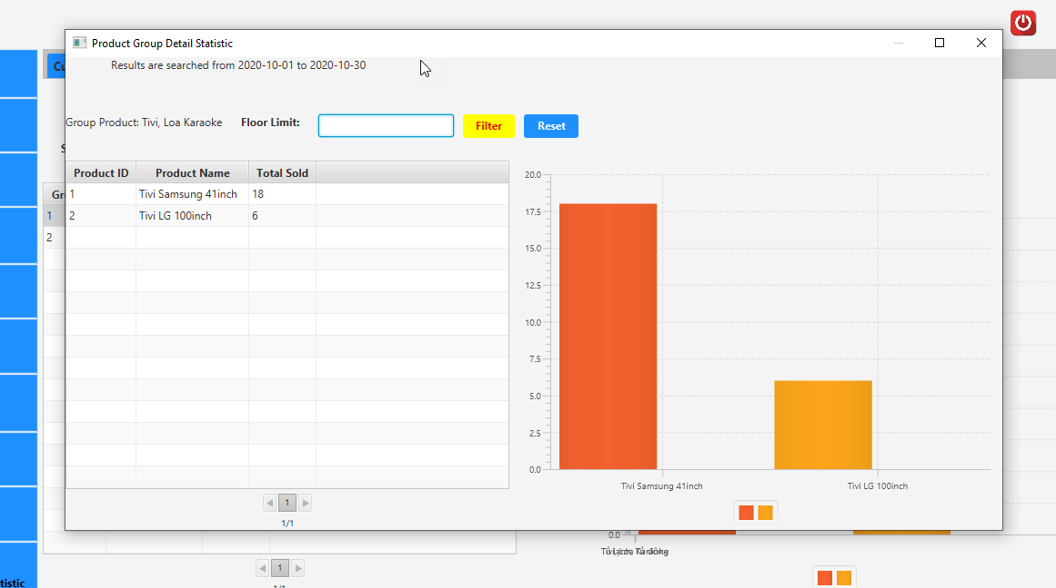

this window will show detail of sales status of product in product group, you can filter what product reached floor limit, if you want to show all result, click reset.

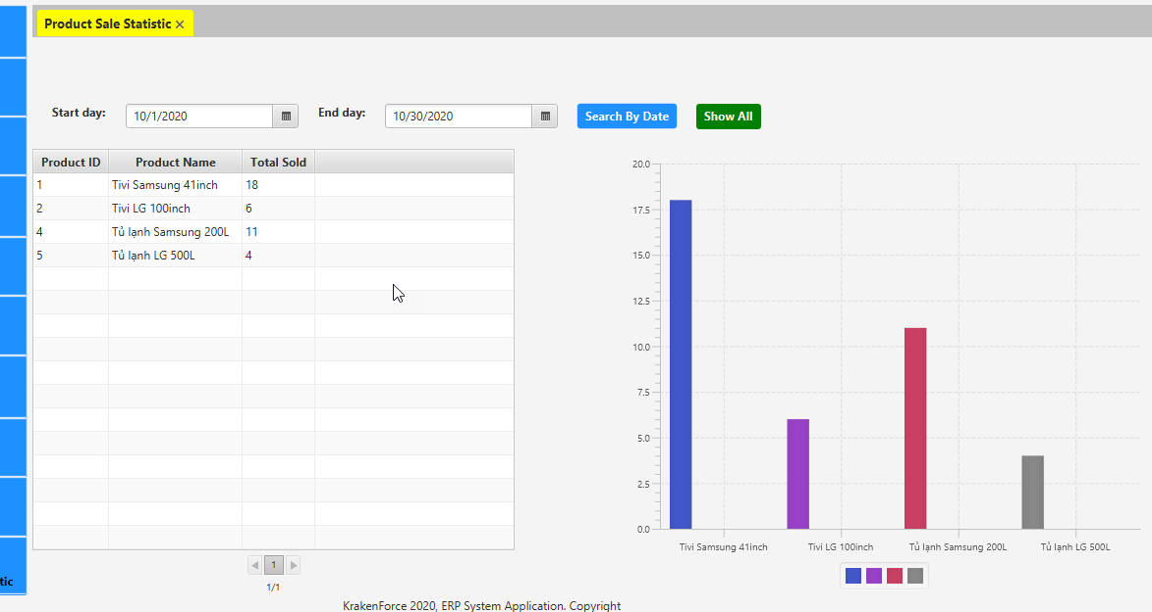

With Product Sale Statistic, select start day and end day and click to search by date, all product that have been sold in specific time will be displayed with total sold amount on table , to show all of all time, click show all

* **Sales Statistic:**

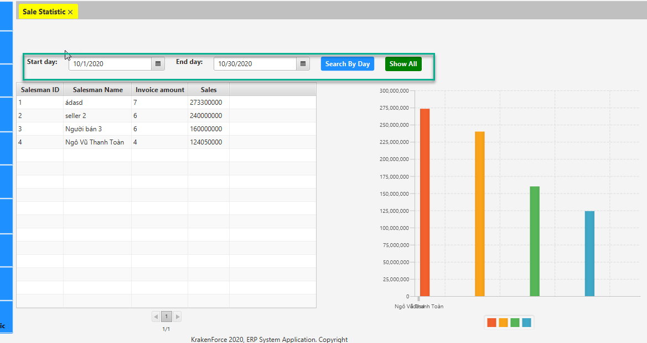

Select start day and end day and click Search By Day to get data that show salesman info, total invoice amount and total Sales in selected time. The chart will be generated by data on table



Github: <https://github.com/krakenforce/ERP_System_Sem2_Project.git>